* **Title Page: cs 1011-051 – Lab 9 <*ParkingLots*>**
* <Denise Malisa>
* <10/11/2020>
* <Page Break>
* **I. Objectives**

The purpose of this lab was for an array to be implemented in the previous lab, lab 8. The program is now facilitating for 20 parking lots in a district. Specific number of parking lots will be open at a time. And depending on how well there are meeting demanding more parking lots will be open if not. Otherwise the program basically serves the same purpose as the previous one.

* **II. Requirements**

An array is created and then the District class is modified to make use of the array. The toString method is introduced in both ParkingLot and District classes, replacing the display method previously used.

* **III. Design:**
* 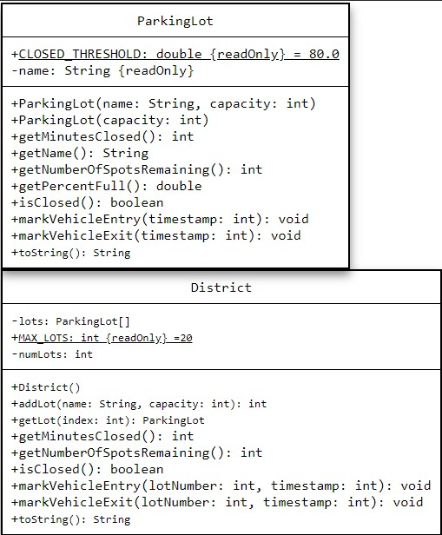

|  |
| --- |
| ParkingLot |
| +CLOSED_THRESHOLD: double {readOnly} = 80.0 -name: String {readOnly}  -capacity: int  -closedStatus: Boolean = false  -availableParking: int  -occupiedParking: int  -totalMintuesClosed: int  -timeClosed: int  -timeOpen: int  -totalTime: int  -previousTime: int |
| +ParkingLot(name: String, capacity: int) +ParkingLot(capacity: int) +getMinutesClosed(): int +getName (): String +getNumberOfSpotsRemaining(): int +getPercentFull(): double +isClosed(): boolean +markVehicleEntry(timestamp: int): void +markVehicleExit(timestamp: int): void +toString(): String |

* **III. Test Plan/Test Strategy**
* The ParkingLotsDriver class was used to check for errors and wrong values for both Classes.
* **IV. Results**
* 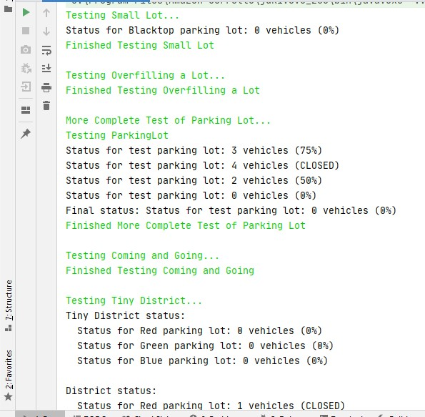
* 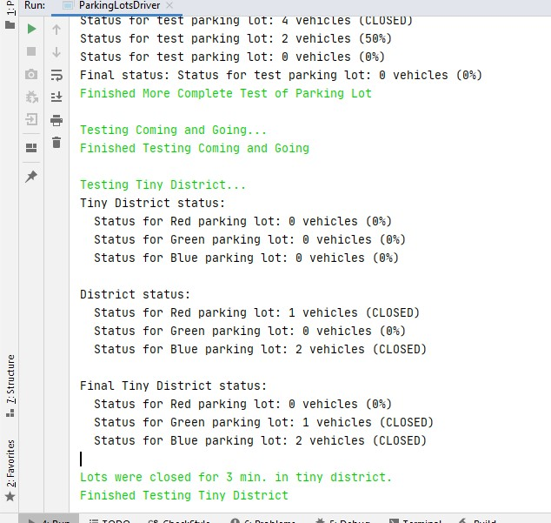
* 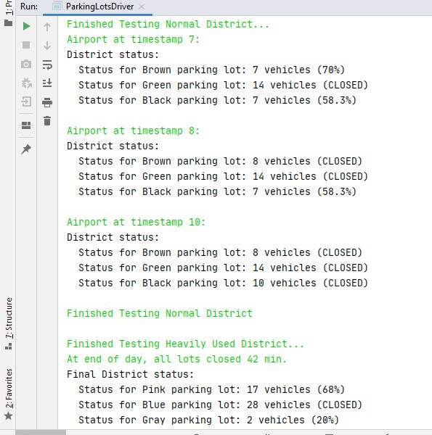
* **V. Discussion**

At first, I thought something was wrong with is closed, but then I realized that the errors I was getting was because of the way I was implementing some of the for loops where it was checking all the spots remaining for each and every parking lot and not just the specific number of lots. Then also the initializations for some values was done at the top so that was wrong e.g. for numberOfLotsClosed. I had major errors at one point all because of casting wrongly in the getPercentFull method in Parking lot. And that also caused wrong value where I was supposed to have 42 mins.